CURRICULUM VITAE
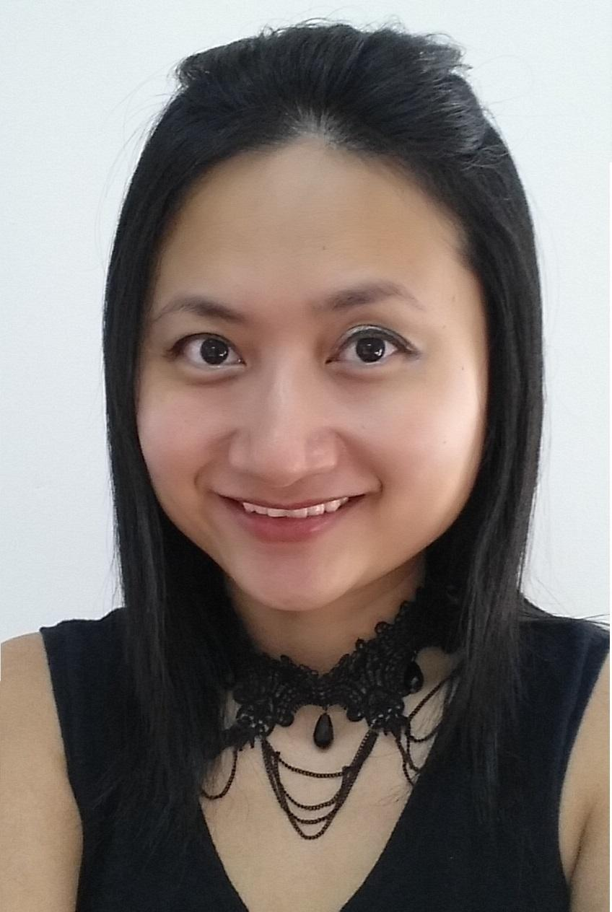
RACHEL TEW CHOON CHYR
add: Bukit Merah view, Singapore 150129
Career Objective
To build a long term career and succeed in an environment of growth and excellence to achieve personal as well as organization goals

Personal Particulars
nric  gender | ● S7885046I  ● female
date of birth | ● 28/06/1978
email  mobile  Marital Status | ● rachel.tewcc@gmail.com  ● 9670 5156  ● Single
language spoken  hobbies | ● English, Mandarin, Cantonese  ● Travelling, Singing, Surfing net
Academic Qualifications
graduate diploma of human capital management, year 2010
Singapore human resources institute

bachelor of commerce (management), year 2000
university of Adelaide, Australia

Other Training
empeiria leadership Technology  individual behavioral competency technology  public presentation mastery  handling grievances, discipline & termination |  | Sep 2013  Aug 2013  Dec 2012  Mar 2011
Personal Attributes
independent, efficient, resourceful , self-motivated, willing to go extra mile, solid analytical and problem solving skill

Professional Experience
HR MANAGER, PICO ART INTERNATIONAL PTE LTD
(INDUSTRY: MICE - MEETINGS, INCENTIVES, CONFERENCING, EXHIBITIONS)
MAR 2015 TO JUN 2016

- Oversee the entire recruitment process including initial validation of hiring request (qualifications, job descriptions, competency, etc), determination of appropriate recruitment mode (newspaper, referrals, existing staff, etc), review resumes, circulate to hiring manager and to arrange interview in a timely manner including conducting reference checks and finally making the offer
- Responsible for the headcount report on a monthly basis
- Assist HR Director to develop an effective compensation and rewards system
- Take charge of staff insurance and medical program
- Review and make recommendation to Staff Handbook to ensure that it is relevant and updated
- Other ad-hoc duties as needed

OFFICE MANAGER CUM PA TO CEO, TOUCH MEDIA NETWORK PTE LTD
(INDUSTRY: ADVERTISING – IN STORE INTERACTIVE MEDIA SPACE)
JAN 2015 TO FEB 2016

- Provides secretarial services to CEO
- Perform HR generalist function and in-charge of office general administration including reception greeting, office petty cash, procurement of office supplies and equipment, office maintenance, travel arrangement （visa/flight/ hotel booking）and etc.
- Act as Company accounts payable and receivable
- Other ad-hoc duties as needed

EA CUM OFFICE MANAGER, DOG DIGITAL (SINGAPORE) PTE LTD
(INDUSTRY: DIGITAL MARKETING, ADVERTISING)
JUN 2012 TO DEC 2014

- Provides day to day administrative support to Managing Director
- Manage overall Human Resource functions, including recruitment, compensation and benefit, learning and development, employee relations, performance appraisal and other ad-hoc issues
- Design, implement and review company HR policies to ensure relevance and competitiveness
- Responsible for office general administration – including reception greeting, office petty cash, procurement of office supplies and equipment, office maintenance, travel arrangement and etc.
- Arranges and coordinate business travel/reservations, corporate event, and handles all confidential material relevant to the company operations.
- Design and maintain e filing system to ensure fast and efficient tracking records
- Act as Company accounts payable and receivable
- Other ad-hoc duties as needed

Key Achievement:
- Successfully transformed a new startup office to a functional, systematic and conducive working environment

EXECUTIVE ASSISTANT CUM OFFICE MANAGER
NOV 2005 TO MAY 2012

I started the role as Personal Assistant to General Manager with Continuity Solutions Pte Ltd in Nov 2005. In year 2007, HQ in Norway set up Global Tender Barges Pte Ltd and I was transferred to assist CEO to set up the office. In year Aug 2011, Global Tender Barges was acquired by KCA Deutag and changed its’ name to KCA Deutag Tender Barges.

3 roles’ job scope as per following;

ROLE 1: PA TO GENERAL MANAGERS, CONTINUITY SOLUTION PTE LTD
(INDUSTRY: SEISMIC EXPLORATION SERVICES, OIL & GAS)
NOV 2005 TO DEC 2007

- Provide secretarial services to 2 expatriate general managers
- Handle office administration, act as HR generalist and accounts payable
- Assist in Tender documents preparation
- Other ad-hoc duties as needed

Key Achievement:
- performance recognition by management and transferred to Global Tender Barges Pte Ltd to assist CEO to set-up the company

ROLE 2: EA CUM OFFICE MANAGER, GLOBAL TENDER BARGES PTE LTD
(INDUSTRY: DRILLING CONTRACTOR, OIL & GAS)

JAN 2008 TO AUG 2011
- Provide full spectrum of secretarial and administration support to CEO & CFO
- Arranges and coordinate schedule, C-level officer business travel, and handles confidential material relevant to the company operations.
- Collate and assist in prepare board meeting presentation
- Organizes and accurately maintains filing system of confidential information
- Supervise admin assistant to maintain professional appearance of office and general administration, including preparing conference room for meeting, pantry and office facilities management. Experience in setting up office and renovation.
- Responsible for the development of HR policies and programs to support the selection and recruitment, compensation & benefits, training and development and employee communications.
- Develop & review the Employee Handbook that details the policies and procedures of the company
- Assist in reviews of group insurances as well as recommending constructive coverage for the company; handle all insurance matters
- Manage Performance Appraisal for the company; track development needs and provide opportunities to further develop skills; coach, motivate and provide support/counsel
- Perform payroll processing, monthly CPF contribution and tax administration
- Handle expatriate compensation and benefits, including employment pass application/renewal/cancellation and relocation arrangement
- Managing the HR information systems from collating, storing and updating of employee information
- Keep track of staff annual leave, medical leave, and etc.

Key Achievement:
- promoted to be office manager after 6 months (pay increment twice within a year);
- self-initiated HR needs and implemented numerous HR policies including employee handbook, performance appraisal system;
ROLE 3: ADMINISTRATOR, KCA DEUTAG TENDER BARGES PTE LTD
(INDUSTRY: DRILLING CONTRACTOR, OIL & GAS)
NOV 2011 TO MAY 2012

- Act as HR generalist and in charge of general office administration for Singapore office
- Assist in offshore crew change coordination

spa supervisor, ritz royal spa center (Guangzhou - China)
(INDUSTRY: BEAUTY & BODY CARE, RETAIL SERVICE)
july 2004 to feb 2005 (own venture)

- Supervise day-to-day business operations
- Design routine service package and promotion according to business needs
- Develop and implement training programs

Cargo sales representative, flytime express int’l company ltd
(Shenzhen, Shanghai, Guangzhou - China)
(INDUSTRY: LOGISTIC)
April 2001 to may 2004

I started the role as customer service officer for one year, within 3 years i have been given a chance to expose to 3 positions in various departments in different offices; customer service officer (Guangzhou), Administrative Manager (Shanghai) and cargo sales representaive (Shenzhen)

CARGO SALES REPRESENTATIVE (SHENZHEN)
- Promote and establish new client account
- Conduct survey for market analysis
- Develop and conduct internal training course

ADMINISTRATIVE MANAGER (SHANGHAI)
- Supervise team of administrators in planning, organizing & executing company's administration activities
- Responsible for the recruitment, selection and performance management

CUSTOMER SERVICE OFFICER (GUANGZHOU)
- To attend to customer enquiries and complaints
- To analyze and process research data to report
- Develop and conduct internal quality service training course
Last Drawn Salary
SGD 4850 + phone allowance S$150/month

Expected Salary
SGD 5500

Earliest Start Date
IMMEDIATE

